

Final Project Report

Submitted By – Vishal Sarjerao Bade
College Name – Dr. D. Y. Patil Pratishthan's College of Engineering Salokhenagar Kolhapur
Branch – Data Science
Roll id – B.Tech 02
Project Name - India's Agricultural Crop Production Analysis

- Introduction
1.1. Project overviews
India's Agricultural Crop Production Analysis is a Data Analytics and Visualization project developed using Tableau. The project analyzes India's agricultural crop production data from 1997 to 2021.
The dataset contains 345,408 rows and 10 columns, covering information related to states, crops, seasons, area, production, and other agricultural parameters. The main purpose of the project is to transform the large agricultural dataset into meaningful and interactive visualizations.
Tableau is used to analyze agricultural production patterns and identify trends based on state, crop, season, year, area, production, and yield.
The project includes multiple visualizations, an interactive dashboard, and a data story that presents the analysis in a simple and understandable format.

1.2. Objectives

The main objectives of the project are:
- To analyze India's agricultural crop production from 1997 to 2021.
- To understand crop-wise production patterns.
- To compare agricultural production across different states.
- To analyze production according to different seasons.
- To identify year-wise production trends.
- To analyze the relationship between area, production, and yield.
- To create interactive visualizations using Tableau.
- To develop an interactive dashboard for data exploration.
- To present the findings through a Tableau data story.
- To provide useful insights for better understanding of agricultural production.

- Project Initialization and Planning Phase
  - Define Problem Statement
Agricultural data contains a large amount of information related to different crops, states, seasons, areas, and production levels. Analyzing such a large dataset using raw data is difficult and time-consuming.
The problem is to analyze this large agricultural dataset and identify meaningful patterns, trends, and variations in India's crop production.
The project aims to answer questions such as:
- Which states have higher crop production?
- Which crops contribute the most to production?
- How does production vary by season?
- How has crop production changed from 1997 to 2021?
- Which areas show higher productivity?
- What is the relationship between production, area, and yield?

  - Project Proposal (Proposed Solution)

The proposed solution is to use Tableau as a data visualization and analytics platform.
The raw agricultural dataset will first be collected and prepared by checking missing values, null values, zero values, data types, and inconsistencies. After preprocessing, the dataset will be connected to Tableau.
Different charts, graphs, maps, KPI cards, and calculated fields will be created to analyze the data.
An interactive dashboard titled "India's Agricultural Crop Production Analysis" will then be developed. Users will be able to apply filters such as State, Crop, Season, Production, Year, and Area.
A Tableau data story will also be created to present the analysis in a logical sequence.

  - Initial Project Planning
The project was planned in the following phases:
Phase |  | Activities
 | Dataset Collection |  | Download agricultural dataset from Kaggle
 | Data Preparation |  | Clean and validate the dataset
 | Data Connection |  | Connect dataset with Tableau
 | Data Exploration |  | Analyze fields, values, and patterns
 | Visualization |  | Create charts, maps, and KPI cards
 | Dashboard |  | Combine visualizations into an interactive dashboard
 | Data Story |  | Present analysis through multiple story scenes
 | Performance Testing |  | Test filters and visualization performance
 | Publishing |  | Publish dashboard to Tableau Public
 | Documentation |  | Prepare project report and links

- Data Collection and Preprocessing Phase

3.1. Data Collection Plan and Raw Data Sources Identified

The agricultural dataset was collected from Kaggle.
The dataset contains agricultural crop production information for India covering the period from 1997 to 2021.
The raw dataset contains:
- State
- Crop
- Season
- Area
- Production
- Year
- Other agricultural-related fields
The dataset contains approximately 345,408 records and 10 columns, with a size of approximately 28 MB.
The downloaded dataset was extracted and stored locally before being connected to Tableau.

3.2. Data Quality Report
The dataset was checked for data quality before visualization.
The following data quality checks were performed:
- Number of rows and columns was verified.
- Column names were checked.
- Data types were verified.
- Missing and null values were identified.
- Zero values were checked.
- Production units were reviewed.
- Duplicate or irrelevant values were considered during preprocessing.
- Area and Production values were checked for consistency.
- Calculated Yield values were verified.
Production values in the dataset are recorded using different units such as:
- Tonnes
- Bales
- Nuts
3.3. Data Exploration and Preprocessing
Data preprocessing was performed before creating the Tableau visualizations.
The preprocessing activities included:
- Connecting the dataset to Tableau.
- Checking column names and data types.
- Identifying null values.
- Handling zero and missing values.
- Checking production units.
- Exploring State, Crop, Season, Area, Production, and Year fields.
- Creating and verifying calculated fields.
- Checking the Yield calculation.
The calculated field used for the analysis was:
Yield = Production / Area
After preprocessing and validation, the dataset was considered ready for visualization and dashboard development.

- Data Visualization
Data visualization is an essential step in data analytics that transforms raw data into meaningful charts, graphs, and dashboards. It enables users to quickly understand trends, compare performance across countries, identify patterns, and make informed decisions.
For this project, Tableau was used to create interactive visualizations that provide insights into global AI adoption in education. Different chart types, filters, and calculated fields were used to represent the data effectively.

4.1. Framing Business Questions
The following business questions were defined for the project:
- What is the total agricultural production in India?
- What is the total yield?
- Which states have the highest agricultural production?
- Which crops have the highest production?
- How does production vary across different seasons?
- How does agricultural production change over the years?
- Which areas contribute significantly to agricultural production?
- How does production vary geographically across India?
- What patterns can be identified from crop and state-level analysis?
These questions helped define the required visualizations and dashboard components.
4.2. Developing Visualizations
A total of 9 unique visualizations were created using Tableau.

Visualization 1: KPI Cards:
KPI cards were created to display important summary information at a glance. The dashboard includes KPIs such as Total Production and Total Yield. These help users quickly understand the overall performance of agricultural production.

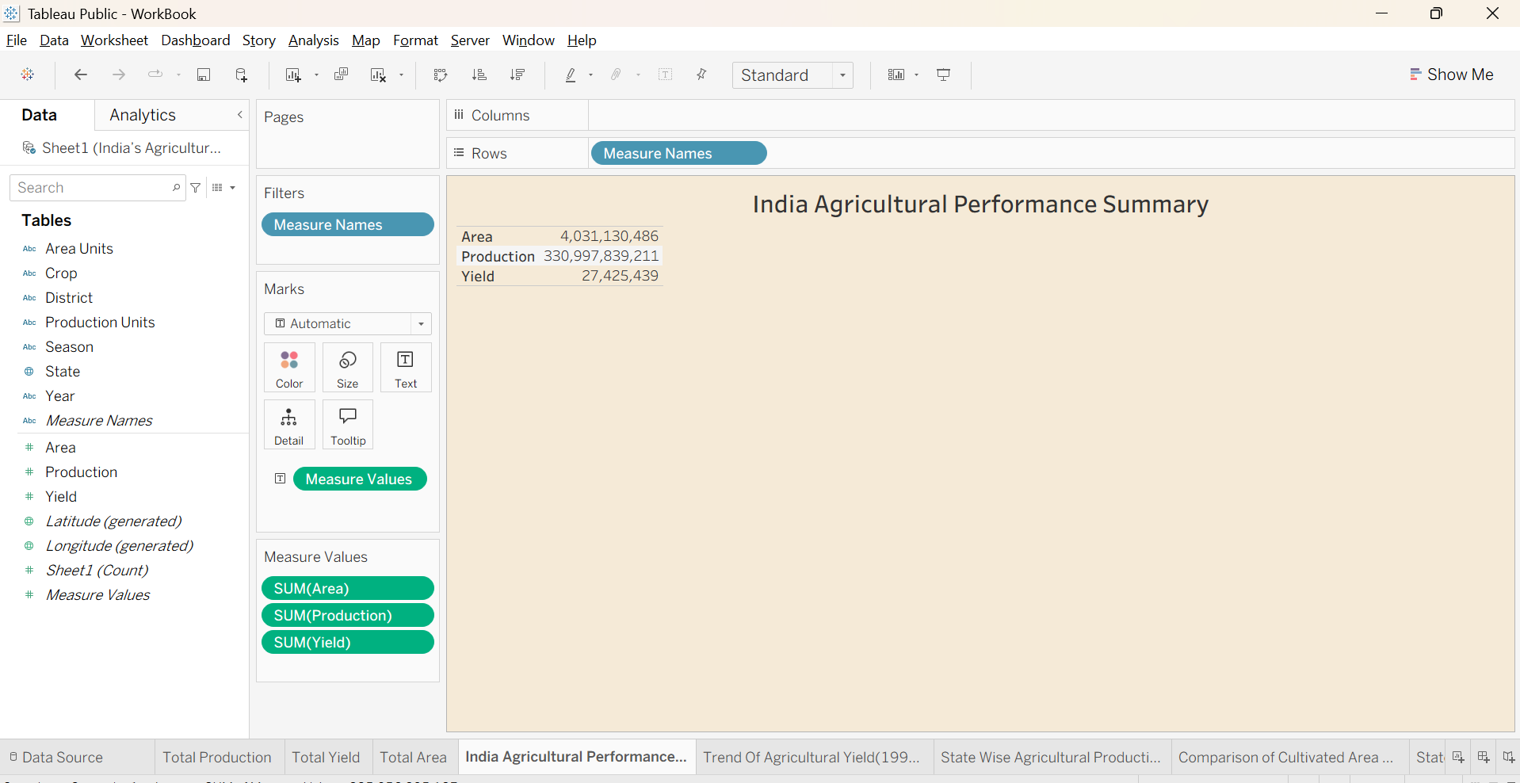

Visualization 2: Line Chart
A line chart was developed to show the year-wise trend of agricultural production from 1997 to 2021. It helps identify increases, decreases, and changes in production over time.
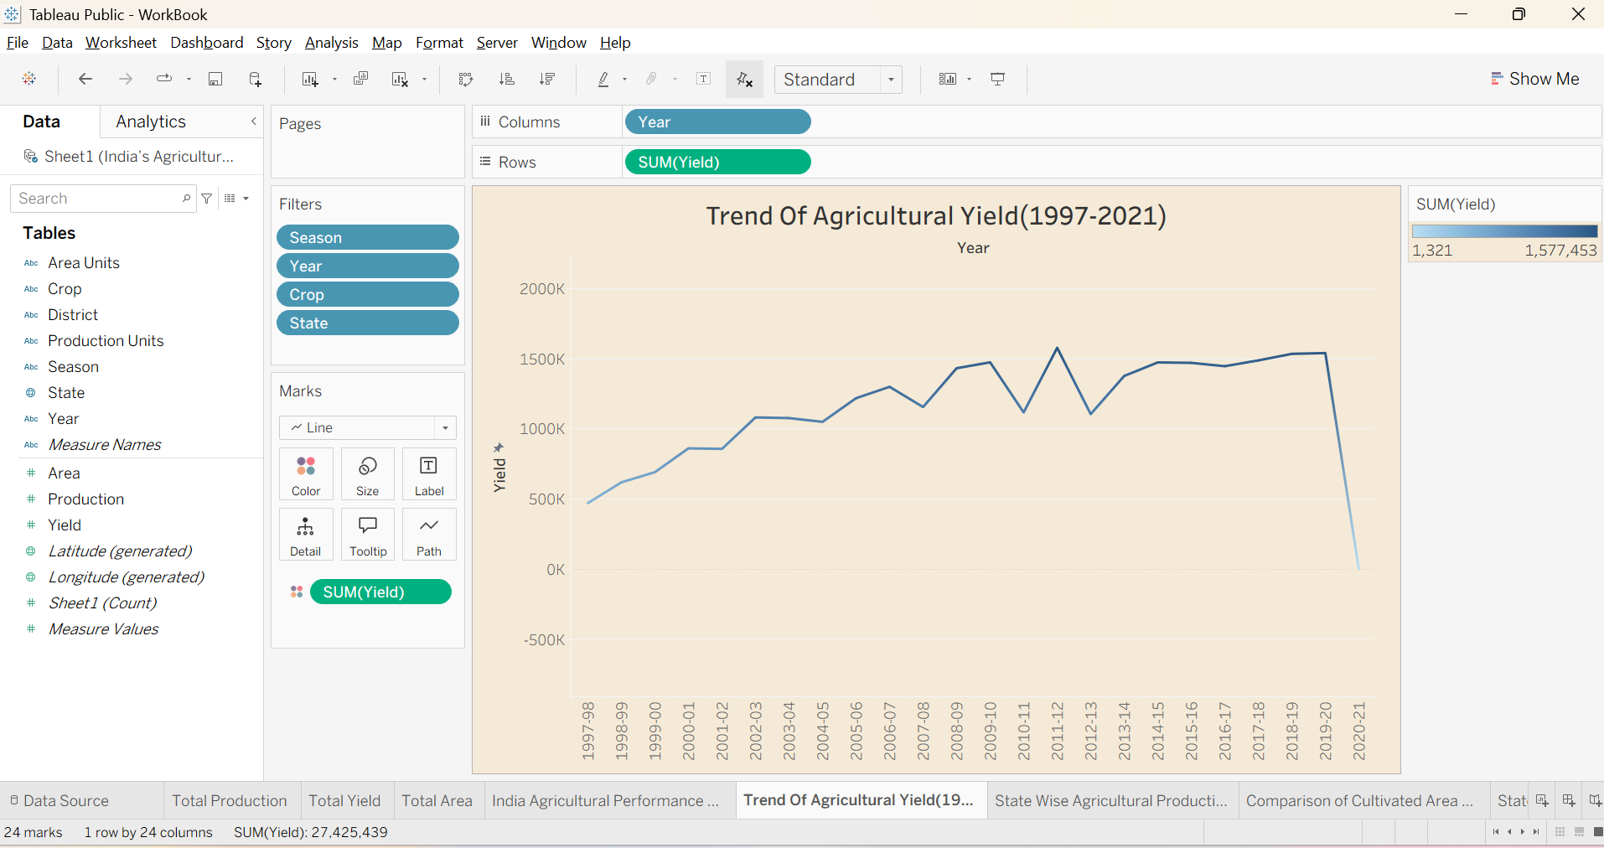

Visualization 3: India Map
An interactive India map was created to show the geographical distribution of agricultural production. Users can compare production across different states and identify states with higher or lower production.

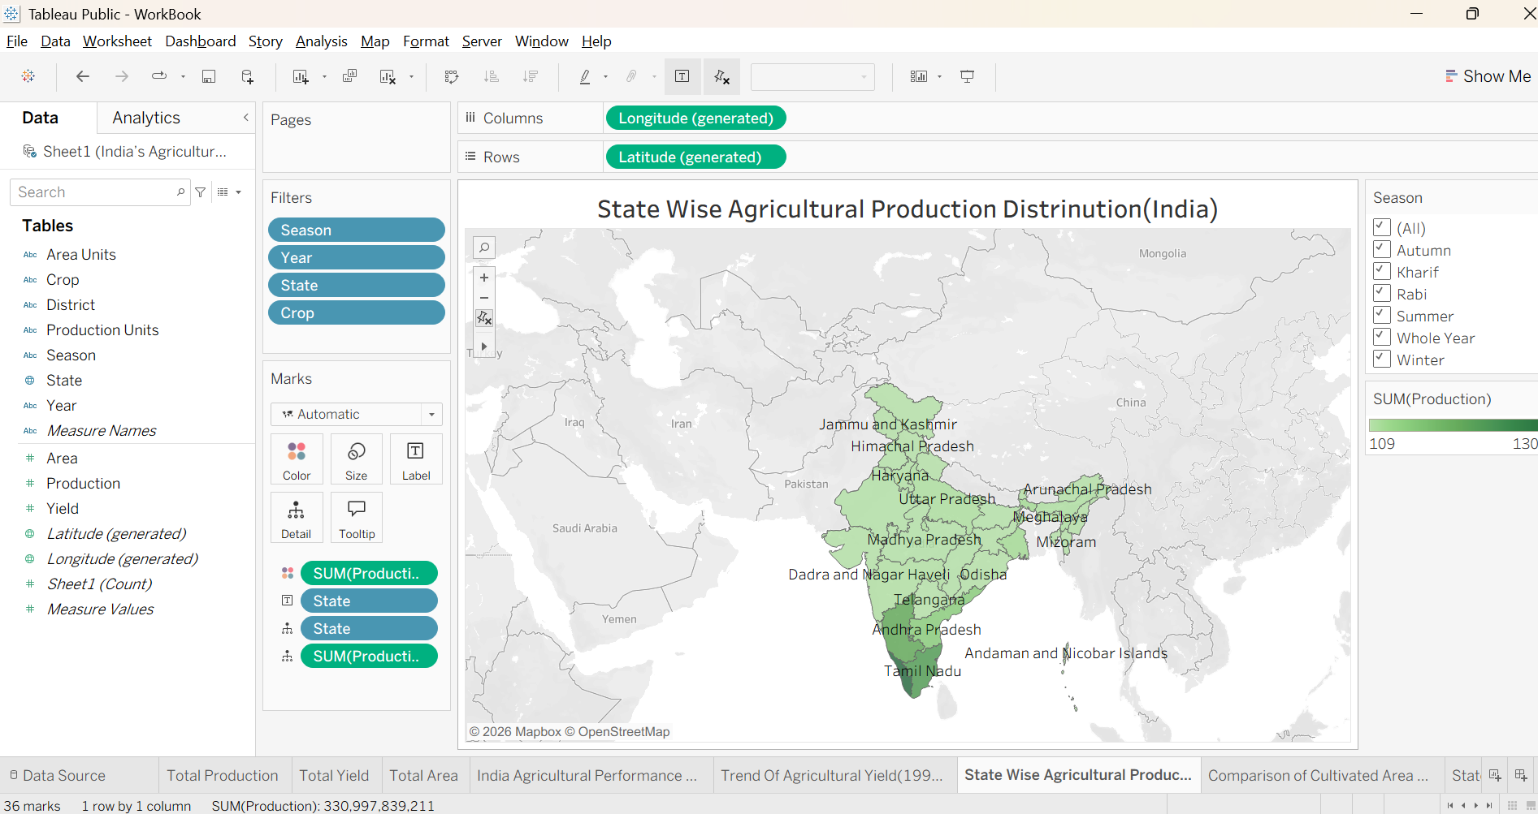

Visualization 4: Horizontal Bar Chart
A horizontal bar chart was used to compare agricultural production across different categories, such as states or crops. It makes it easy to rank and compare values.

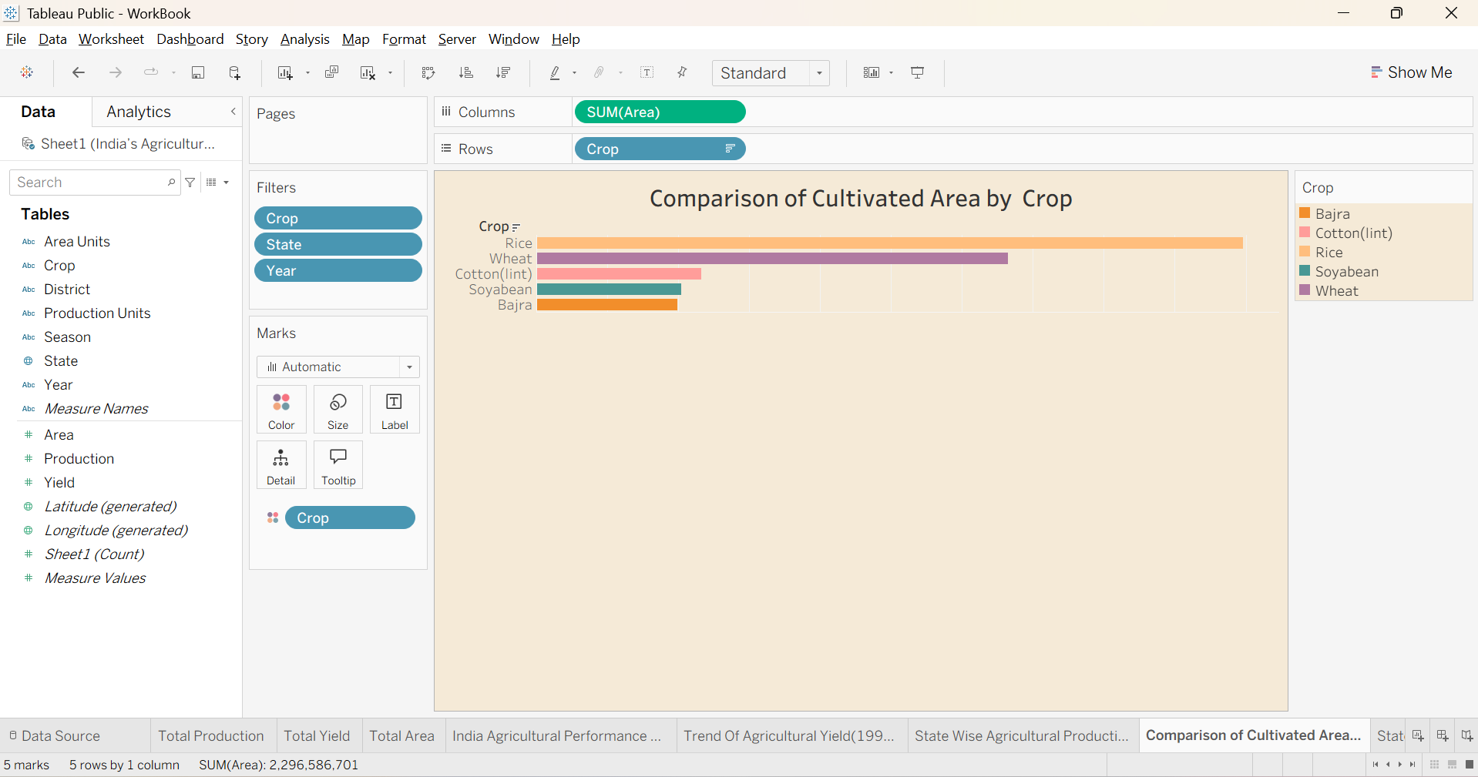

Visualization 5: Grouped Bar Chart
A grouped bar chart was developed to compare multiple categories together. It can be used to analyze crop-wise or season-wise production and understand differences between categories.

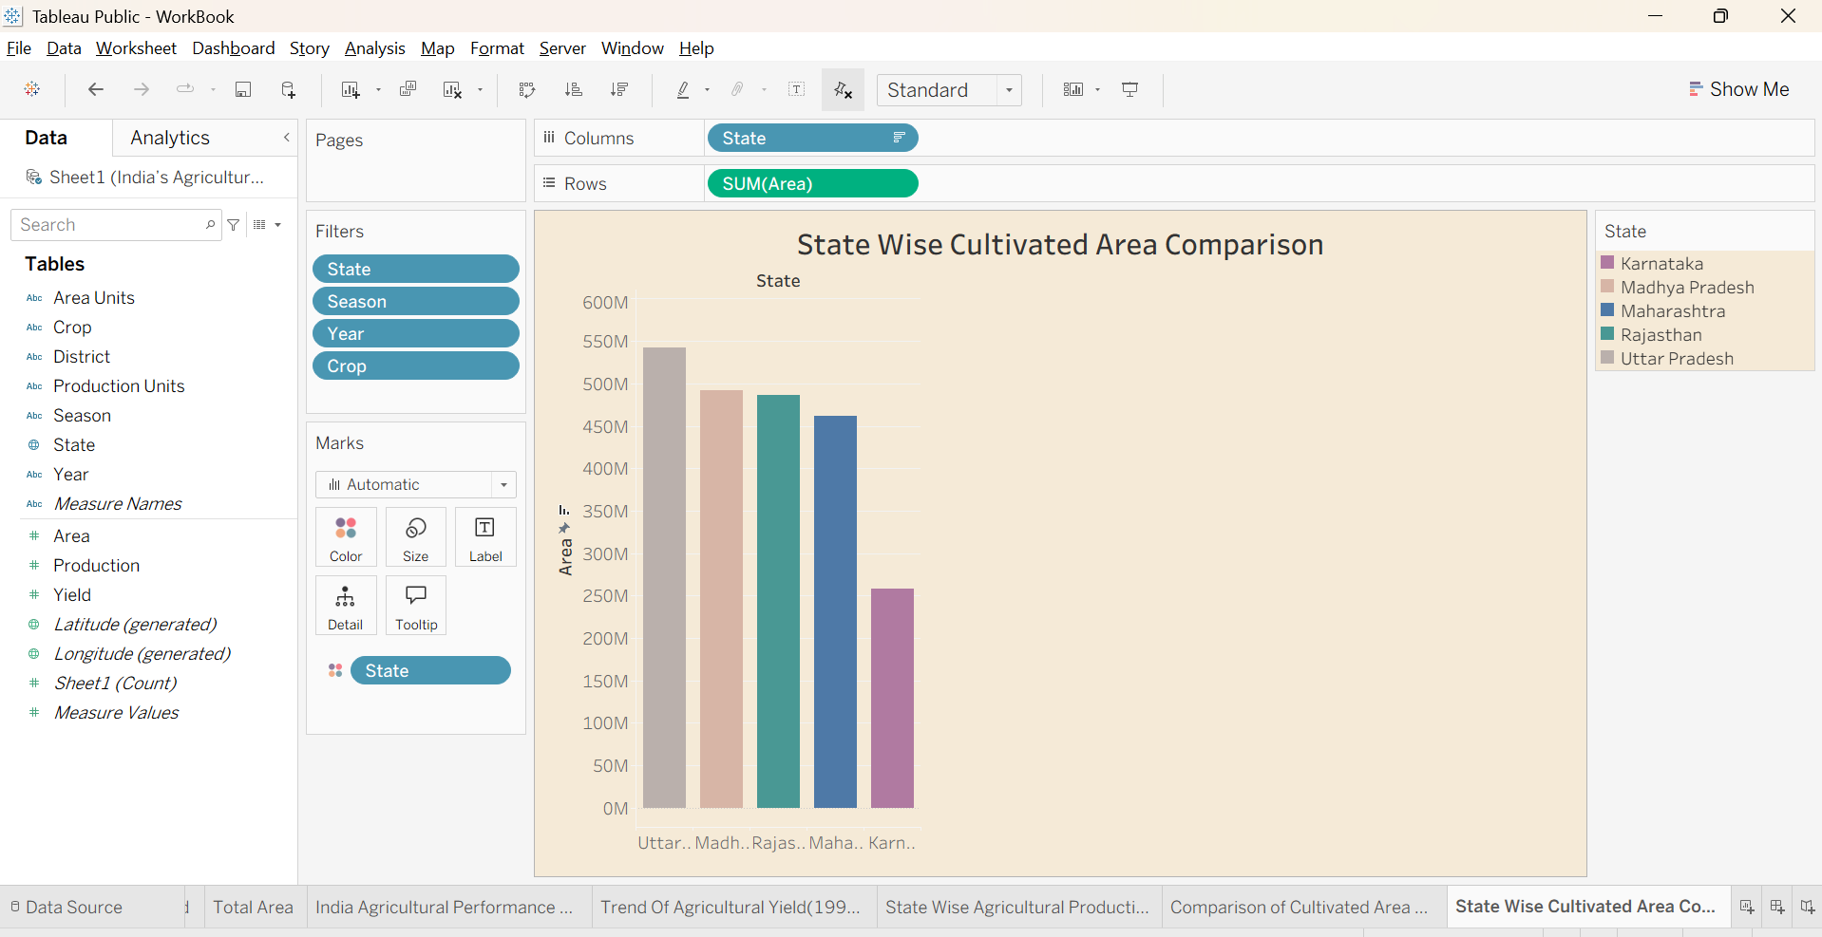

Visualization 6: Donut Chart
A donut chart was created to show the proportion or contribution of different categories to agricultural production. It provides a simple visual representation of distribution.

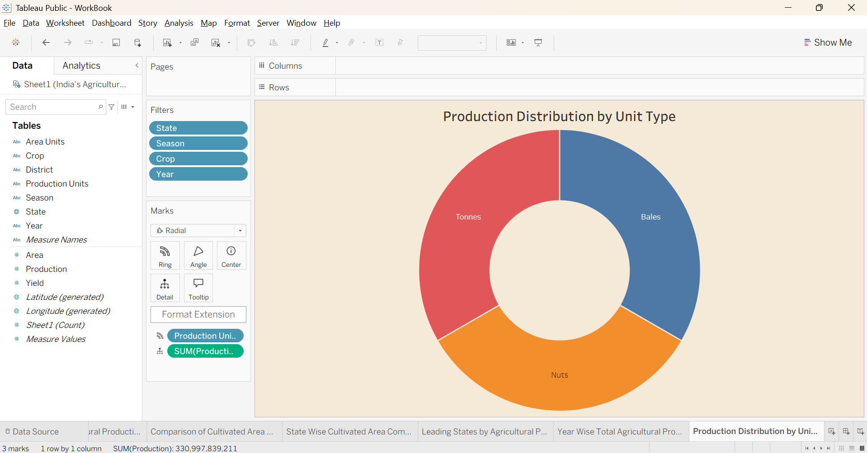
Visualization 7: Pie Chart
A pie chart was used to represent the percentage contribution of different crops, seasons, or other categories. It helps users understand which categories have a larger or smaller share.

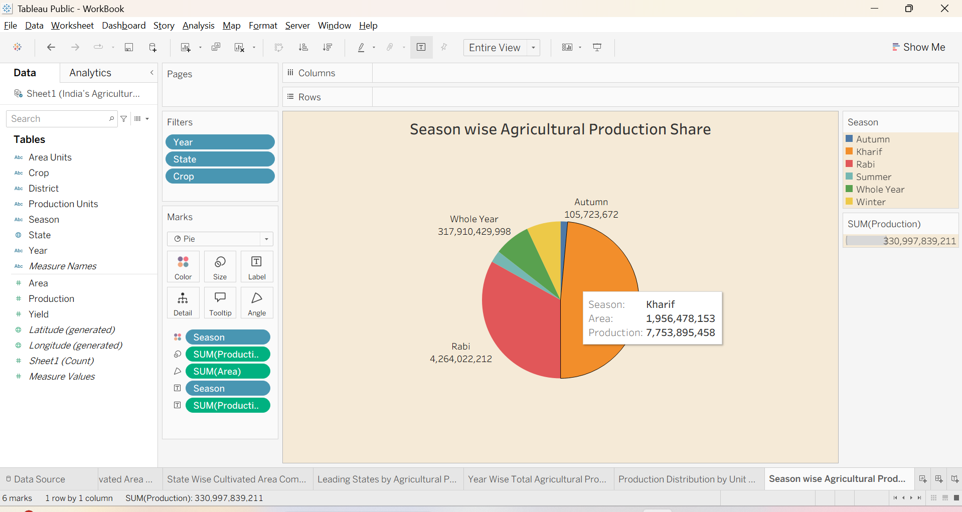

Visualization 8: Crop-wise Analysis
Crop-wise visualization was developed to compare production among different crops. This helps identify the crops that contribute significantly to India's agricultural production and understand their relative performance.
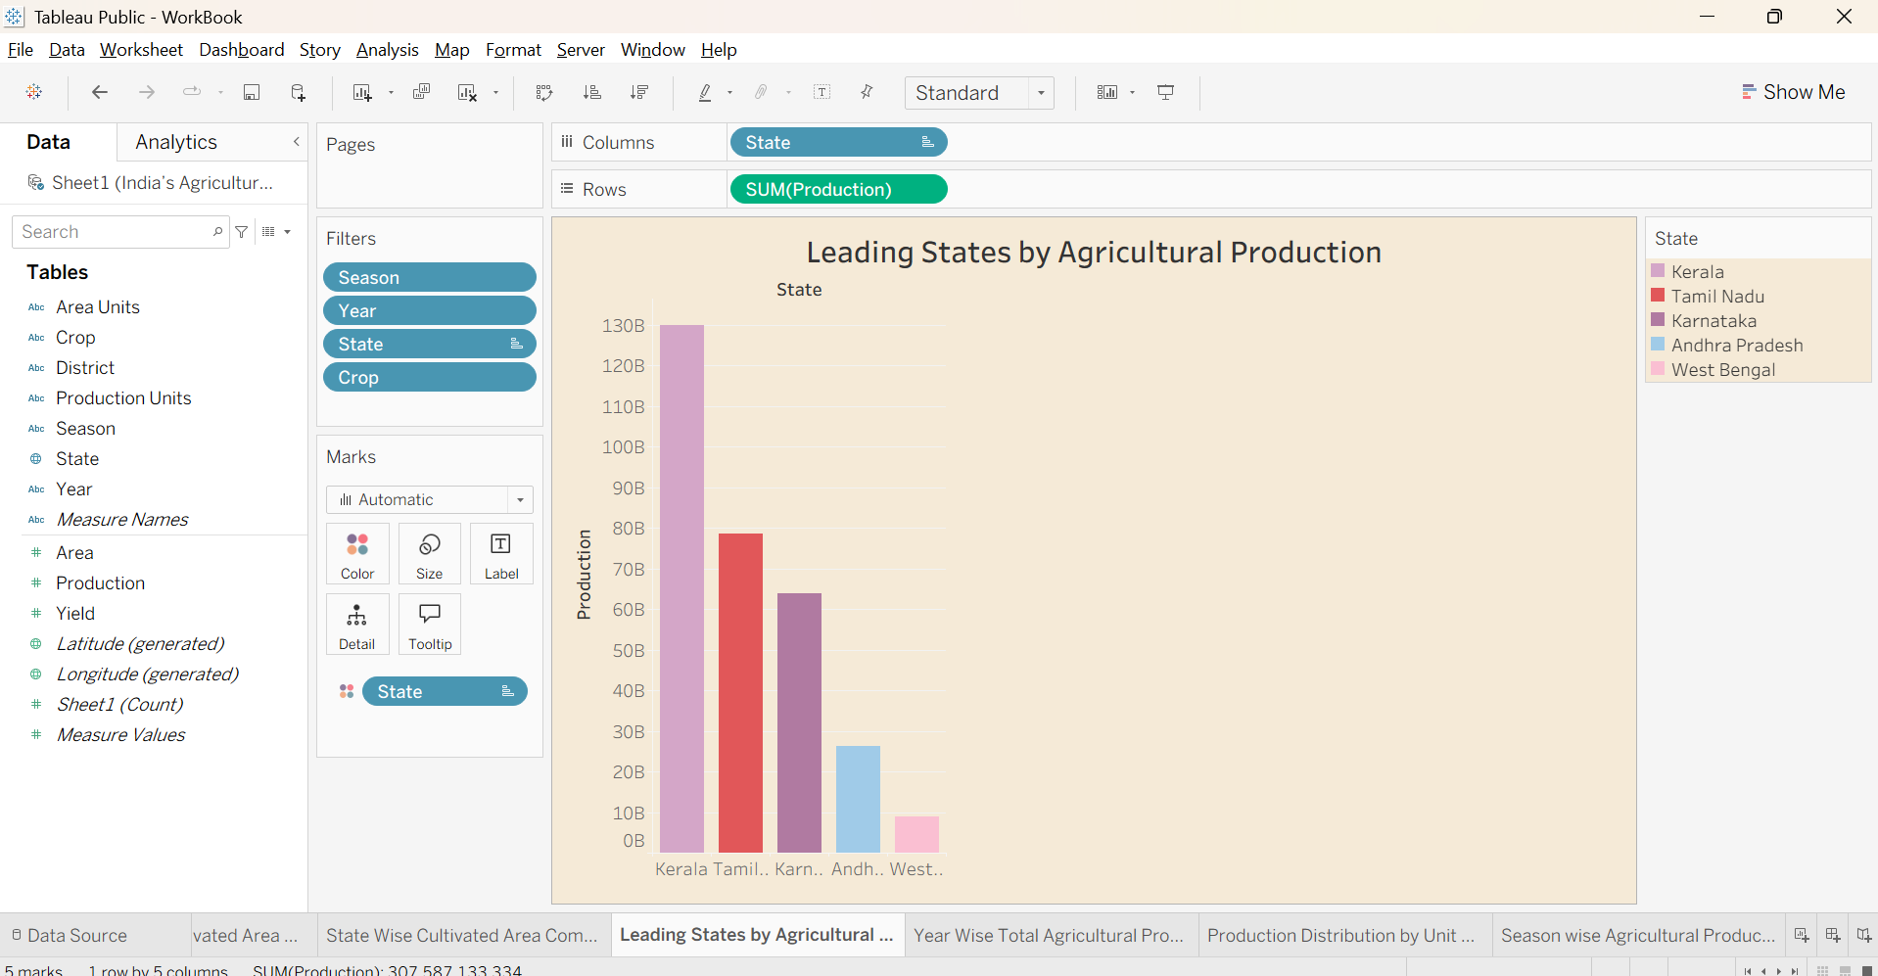

Visualization 9: State-wise and Season-wise Analysis
State-wise and season-wise visualizations were created to compare agricultural production across different states and seasons. This helps identify regional differences and understand how production varies according to the agricultural season.

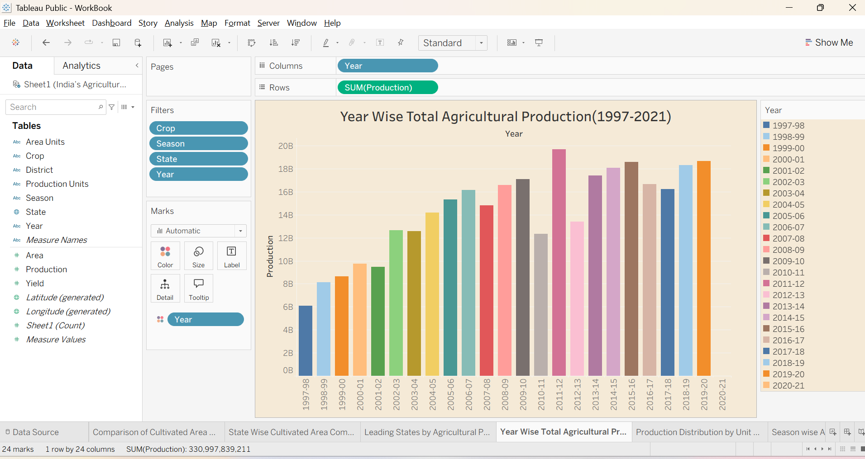

- Dashboard
5.1. Dashboard Design File
The main Tableau dashboard is titled:
"India's Agricultural Crop Production Analysis"
The dashboard combines multiple visualizations into one interactive view.
The dashboard contains:
- Project title
- Total Production KPI
- Total Yield KPI
- Six major charts
- Interactive filter panel
- State-wise analysis
- Crop-wise analysis
- Season-wise analysis
- Year-wise analysis
- Geographic analysis
The dashboard uses a beige/cream background to provide a clean and professional appearance.
The charts are arranged in a 2×3 grid layout, while the filter panel is placed on the right side.
Users can dynamically filter the dashboard using:
- State
- Crop
- Season
- Production
- Year
- Area
When a filter is selected, the related charts automatically update, allowing users to perform interactive analysis.

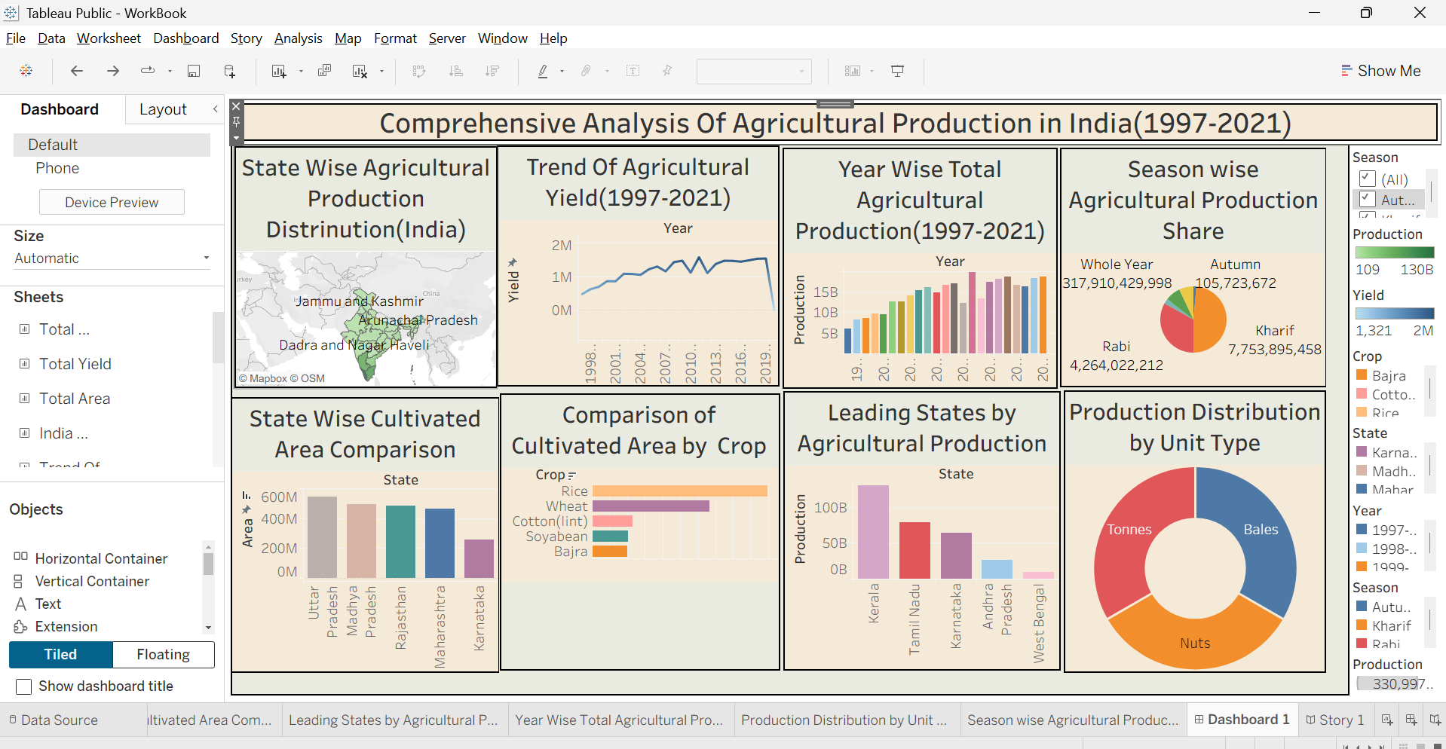

- Report
6.1. Story Design File
A Tableau data story was created to present the findings of the “India's Agricultural Crop Production Analysis” project in a logical and easy-to-understand sequence.
The story is divided into multiple story points, with each point focusing on a specific aspect of India's agricultural production from 1997 to 2021.

Story Name: India's Agricultural Crop Production Analysis

Story Point 1: Overall Agricultural Production
- Displays the overall agricultural production using KPI cards.
- Shows important metrics such as Total Production and Total Yield.
- Provides a quick overview of India's agricultural production.
- Helps users understand the overall scale of agricultural production.

Story Point 2: Geographic Distribution
- Displays agricultural production across Indian states using an India map.
- Highlights differences in agricultural production between states.
- Helps identify states with higher and lower production.
- Provides a clear understanding of the geographical distribution of agricultural activities.
Story Point 3: State-wise Production
- Compares the total agricultural production of major states using a horizontal bar chart.
- Karnataka records the highest total production in the analysis, followed by other major agricultural states.
- Helps identify the major contributors to India's agricultural production.
- Provides useful information for understanding state-level agricultural performance.

Story Point 4: Cultivated Area by State and Crop
- Compares the cultivated area across major states, segmented by crop type.
- Uttar Pradesh has the highest cultivated area, followed by Madhya Pradesh, Rajasthan, and Maharashtra.
- Shows that crops such as rice and wheat occupy significant cultivated areas in northern states.
- Cotton and soyabean are prominent in central and western regions.
- Helps understand how cultivated land is distributed across states and crops.

Story Point 5: Crop and Season Analysis
- Compares agricultural production across different crops and seasons.
- Highlights variations in crop production based on agricultural seasons.
- Helps identify important crops and their seasonal production patterns.
- Provides a better understanding of the relationship between crops and growing seasons.

Story Point 6: Year-wise Production Trends
- Shows changes in agricultural production from 1997 to 2021 using a line chart.
- Highlights increases and decreases in production over the years.
- Helps identify long-term agricultural production trends.
- Provides an understanding of how India's agricultural production has changed over time.

Story Point 7: Area, Production and Yield Analysis
- Analyzes the relationship between cultivated area, production, and yield.
- Uses the calculated field Yield = Production / Area.
- Helps identify areas where higher production is associated with larger cultivated areas.
- Provides insights into agricultural productivity and efficiency.

- Performance Testing
Performance testing was conducted to ensure that the Tableau dashboard works efficiently with the complete dataset.
The dataset contains:
- Rows: 345,408
- Columns: 10
- Approximate Size: 28 MB
- Number of Visualizations: 9
7.1. Utilization of Data filters
Interactive filters were tested to evaluate dashboard responsiveness.
The following filters were used:
- State
- Crop
- Season
- Production
- Year
- Area
The filters allow users to select specific data and dynamically update the visualizations.
Tableau handled the filters efficiently without significant performance issues.
7.2. No of Calculation Field

Calculated fields were created where required for analysis.
The major calculated field used in the project is:
Yield = Production / Area
The calculated field was verified to ensure that it produced meaningful values for the analysis.

7.3. No of Visualization
A total of 9 unique visualizations were created.
These include KPI cards, line charts, maps, bar charts, grouped charts, donut charts, and pie charts.
Tableau handled the complete dataset efficiently, and the visualizations rendered within acceptable time limits.

- Conclusion/Observation

The India's Agricultural Crop Production Analysis project successfully transformed a large agricultural dataset into meaningful and interactive visualizations using Tableau.
The project analyzed 345,408 records covering India's agricultural production from 1997 to 2021.
The dashboard provides insights into:
- Overall agricultural production
- Total yield
- State-wise production
- Crop-wise production
- Season-wise production
- Year-wise production trends
- Geographical distribution
- Relationship between area, production, and yield
The interactive filters make it easy for users to explore specific states, crops, seasons, years, production values, and areas.
Overall, the project demonstrates how data analytics and visualization can convert complex agricultural data into understandable and useful information.

- Future Scope

The project can be further improved in the following ways:
- Real-time Data Integration
Connect the dashboard with regularly updated agricultural datasets.
- Agricultural Production Forecasting
Machine learning models can be added to predict future crop production.
- Weather Data Integration
Weather conditions such as rainfall, temperature, and humidity can be integrated to study their effect on crop production.
- Soil Data Analysis
Soil type and soil quality data can be combined with crop production data.

- Appendix

10.1. GitHub & Project Demo Link

Project Demo Link - https://india-s-agricultural-crop-productio-alpha.vercel.app/

GitHub Link –
https://github.com/Vishal-Bade/India-s-Agricultural-Crop-Production

